Karina Sirabian 11/10/20

***The Effect of Covid-19 Government Mandated Shut-Downs on***

***Air Pollution in New York City***

**Background:**

In the modern world, air pollution is one of the most serious environmental issues due to its harmful impact on both the natural ecosystem and human health. Air pollution is often caused by solid and liquid particles suspended in the air called particle matter (PM). There are different categories of particle matter dependent on the diameter of the particle; however, PM2.5 (2.5 $μm$ in diameter) is heavier and tends to settle in the air for longer periods of time. PM2.5 is formed as a result of burning fuel and chemical reactions that take place in the atmosphere and is most commonly produced by transportation vehicles, the burning of fossil fuels, factories, indoor air pollution, and construction/demolition. PM2.5 is also the primary source of smog. For major cities, air pollution is a much more apparent problem because of the increased amounts of traffic, factories/industries, construction, and harmful human activities, which produce higher amounts of PM2.5.



*New York City Smog Emergency, November 1966*

Historically, New York City has had air pollution problems due to all of the harmful human activities done there that produce PM2.5. In November 1966, there was a smog emergency in NYC where a combination of sulfur dioxide and carbon monoxide encapsulated Manhattan killing 169 to 400 people and before that there was also a similar smog emergency in 1953. In general, the air pollution in NYC in the 1960’s was bad, but with the creation of the EPA in 1970, the air pollution in NYC has gotten better, but the problem still remains. Currently in NYC, PM2.5 levels contribute to nearly 2300 deaths and 6300 emergency department visits and hospitalizations for respiratory and cardiovascular disease each year, so air pollution is still a major issue in NYC.

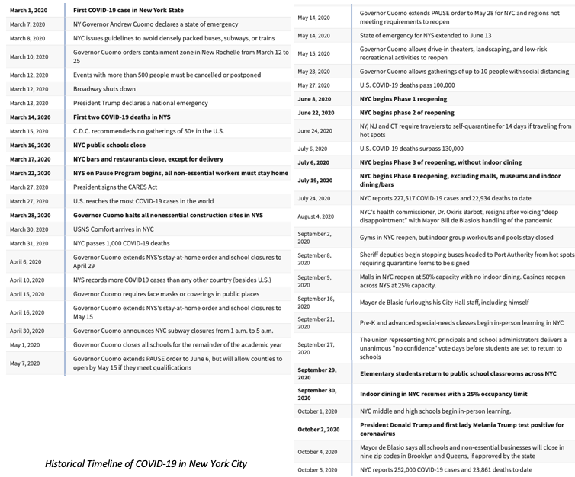

Due to the recent Covid-19 Outbreak, many cities all around the world were forced to shut-down leaving people to quarantine in their homes to prevent the spread of the virus. On March 1st, 2020 the first COVID-19 case was recorded in New Rochelle, NY, a suburb just outside of New York City and on March 14th, 2020 the first two COVID-19 deaths were recorded in NYC. Throughout March, people were advised to not use densely packed public transportation, major events were cancelled, Broadway shut down, public schools, bars, and restaurants (except delivery) closed, all non-essential workers were told to stay home, and all nonessential construction sites were halted. Throughout April and May, NYC as a whole was pretty much shut down and there was significantly less human activity going on; especially human activity that produced PM2.5. Throughout June and July, New York City started to slowly open up again in 4 stages, but even today there is still less going on. Additionally, New York state has many travel restrictions limiting the amount of tourists visiting New York City. Overall, due to the current pandemic, NYC is much less active than it has been in previous years, and during the government shutdown period, there was less traffic/transportation, operating factories, construction, and overall harmful human activity that would produce PM2.5.

**Objective:**

One of the main causes of air pollution is harmful human activities including transportation, construction, burning of fossil fuels, and factories; however, during the NYC government mandated shutdown, people were forced to quarantine in their homes reducing the amount of these harmful activities. This brings us to the main objective, which is to examine if the amount of air pollution in NYC decreased due to the decrease in human activity. To further look at this, we need to figure out if there was a statistically significant decrease in air pollution during the NYC government mandated shutdown.

**Methods:**

To determine if air pollution in New York City during the government shutdown period decreased, air pollution measurements were compared from before the shutdown period to during the shutdown period. These two periods were defined to be the *pre-shutdown period* (January 1st – March 16th) and the *shutdown period* (April 1st – June 8th). March 16th was chosen as the end of the pre-shutdown period because that is when NYC public schools closed and it is the date of the first official closing in NYC. Even though March 22nd was the official date of the NYS on pause program (non-essential workers stay home) and all non-essential construction stopped on March 28th, April 1st was chosen as the shutdown start date because air pollution does not disappear right away, so we gave a few days to be able to see an air pollution difference. June 8th was chosen as the shutdown end date because that is when NYC entered phase 1 reopening. Thus, by comparing the air pollution from the pre-shutdown period to the shutdown period, it can be determined if the government mandated shutdown had a significant effect on the air pollution.

There are many different types of air pollution all produced by different things; however, since almost everything stopped in NYC, the air pollutant created by the biggest array of human activity needed to be measured to encapsulate the government shutdown: this pollutant is PM2.5. Measurements of PM2.5 have the ability to represent air pollution due to transportation, construction, burning of fossil fuels, and factories, thus reflecting how NYC was shutdown. Data for measurements in PM2.5 was taken from the EPA’s outdoor air quality data base, which measures the daily mean PM2.5 concentration for different sites. There were 12 sites located in NYC on the EPA data base, but 3 of those sites had measurements from two instruments, so they will be omitted. The following sites located throughout New York City were examined: City College of New York (CCNY), Freshkills West, Intermediate School 143, Intermediate School 74 (IS 74), Maspeth Library, Morrisania, Pfizer Lab Site, PS 274, and PS 314.

Even though the government shutdown took place in 2020, it is important to look at air pollution data from previous years in case there is a bigger air pollution trend that is occurring with time. Thus, the same analysis of comparing the pre-shutdown period and the shutdown period will be done not just for 2020 but from the past 5 years (2015-2020). Since we are looking at multiple years, normally the ANOVA test would be used to compare the mean daily PM2.5 concentration during the pre-shutdown period and the shutdown period; however, since all of the data did not meet the assumptions of the ANOVA test (normality and equal variance), the Kruskal Wallis test was used to compare the mean daily PM2.5 concentration across all 5 years during the pre-shutdown period and the shutdown period. It is not enough to simply compare the data for each year to the pre-shutdown period to the shutdown period using a two-sample t test because if there is a trend throughout time (i.e. air pollution is consistently decreasing), then a two-sample t test would show a difference in data that would not be due to the government shutdown. Thus, the Kruskal Wallis test was used to look for a change in the air pollution trend from the pre-shutdown period to the shutdown period in 2020 compared to the past 5 years.

The results of the Kruskal Wallis tests for each site can be broken down into 4 basic categories each with its own conclusion for if the government shutdown had a statistically significant effect on the amount of air pollution:

|  |  |  |
| --- | --- | --- |
|  | Pre Shutdown Period Mean Daily PM2.5 Concentration was the same across all years | Pre Shutdown Period Mean Daily PM2.5 Concentration was *not* the same for 2020 as previous years |
| Shut Down Period Mean Daily PM2.5 Concentration was the same across all years | The government shutdown had no significant effect on the PM2.5 concentration | The year 2020 was already different than previous years (no evidence of government shutdown effect with Kruskal Wallis Test) |
| Shut Down Period Mean Daily PM2.5 Concentration was *not* the same for 2020 as previous years | **The government shutdown had a significant impact on the PM2.5 concentration** | The government shutdown had no significant effect on the PM2.5 concentration |

*Table 1: Combinations of possible results expected from the Wilcoxon Rank Sum Test and their meanings*

However, since we compared 2020 to multiple years, the results of the tests (either ANOVA or Kruskal Wallis) were not as straightforward as the table above because of the possibilities that some years are different than 2020 and others are not. Additionally, if there is a possible correlation between air pollution and time of year in general and it so happens to align with our predefined pre-shutdown and shutdown periods, then this also complicate the table above. For example, if air pollution is higher in the winter (which would align with our pre-shutdown period) and decreases in the Spring (aligning with our shutdown period), then the table would say that the government shutdown had a significant impact on the PM2.5 concentration; however, it could just be a seasonal occurrence. Thus, if there is a seasonal pattern, we would have to compare the change from the two periods across all years and determine if the change in 2020 was more drastic than in previous years.

If the results showed that the government shutdown had a significant impact on the PM2.5 concentration, the last step would be to simply compare the mean daily PM2.5 concentration during the shutdown period in 2020 to that of previous years to see if the air pollution in 2020 was less than in previous years.

**Results and Analysis:**

After running the Kruskal Wallis Test and the Wilcoxon Rank Sum Test on the data and looking at summary statistics, we do not have statistical evidence to suggest that the air pollution in NYC decreased or was effected by the New York City government mandated shutdowns. More interestingly, the reason we do not have statistical evidence is because the air pollution in the pre-shutdown period is higher than in the shutdown period across *all* years and across all sites, thus any decrease in air pollution in 2020 cannot be credited solely to the government shutdown. Generally, the decrease in air pollution in 2020 was relatively the same as the decrease in air pollution across all 5 years; however, a statistical test could not officially and accurately be done on this due to a small sample size of 5 years. Ultimately, the data shows a rather consistent seasonal decrease in PM2.5 concentration across all years, where the decrease in 2020 is not statistically different than the decrease from other years; however, some sites do show evidence that 2020 had a greater decrease in the PM2.5 daily mean concentration than in past years, which could be due to the Covid-19 shutdowns.

City College of New York (CCNY) Results/Analysis:

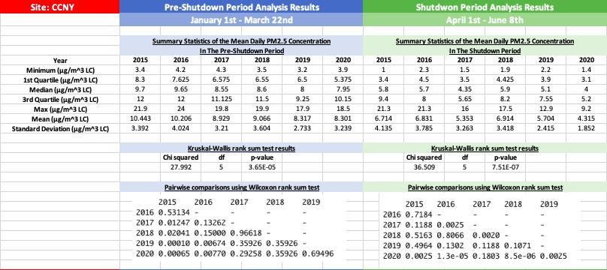

*Figure 1: Summary Statistics and Results of the Kruskal Wallis Test and the Wilcoxson Rank Sum test for CCNY*



*Figure 2: Comparison of PM2.5 levels during the pre-shutdown and shutdown period in CCNY*

As seen in figure 2, the Daily Mean PM2.5 Concentration in CCNY is greater during the pre-shutdown period than in the shutdown period. Throughout all 5 years, the minimum, 1st quartile, median, 3rd quartile, maximum, and mean daily mean PM2.5 concentration in the pre-shutdown period are greater than during the shutdown period. However, it is interesting that the standard deviation of the daily mean PM2.5 concentration doesn’t really change from the pre-shutdown period to the shutdown period during except for in 2020 where the standard deviation goes from 3.239 $μ$ g/m^3 to 1.852 $μ$ g/m^3 (Figure 1). This shows that the measurements in 2020 were consistently more lower than in past years and there were no larger measurements.

Based on the results of the Kruskal Wallis Test (Figure 1) , the chi squared value is 27.992 with a p-value of 3.65e-5 for the pre-shutdown period and a chi squared value of 36.509 with a p-value of 7.51e-07 meaning that during both periods, the PM2.5 daily mean concentrations for each year was statistically different and that the group medians are not equal. However, looking at the results from the Wilcoxon rank sum test, we can see that during the pre-shutdown period, the p-values comparing 2020 with 2017, 2018, and 2019 are 0.293, 0.359, and 0.695, which are all greater than 0.05 meaning that we have evidence to suggest that the PM2.5 medians were the same across for 2020 as 2017-2019 during the pre-shutdown period. Since the p-values comparing 2020 to 2015 and 2016 (0.00007 and 0.008) were less than 0.05, this suggest that the PM2.5 levels were different from 2020 so referring back to table 1, with the Kruskal Wallis test and the Wilcoxon test we cannot compare the PM2.5 concentration change from the pre-shutdown period to the shutdown period for these years because they originally started out different. However, during the shutdown period, the p-values comparing 2020 with 2017, 2018, and 2019 are 0.180, 8.5-06, and 0.003. With this, the 2020 median is not statistically different than 2017; however, comparing 2018 and 2019 to 2020, we see that 2020 had a greater decrease in PM2.5 air pollution than in 2018 and 2019 because during the pre-shutdown period, we had evidence that the medians were the same, but during the shutdown period we see that the distributions are statistically different and since the median daily PM2.5 concentration in 2020 (4 $μ$ g/m^3 ) is less than the median daily mean PM2.5 concentrations in 2018 and 2019 (5.9 $μ$ g/m^3 and 5.1 $μ$ g/m^3 ), then we can see that the daily mean PM2.5 concentration in CCNY decreased more in 2020 during the shutdown period than it did during 2018 and 2019, which could be due to the government shutdown.

Freshkills West Results/Analysis:

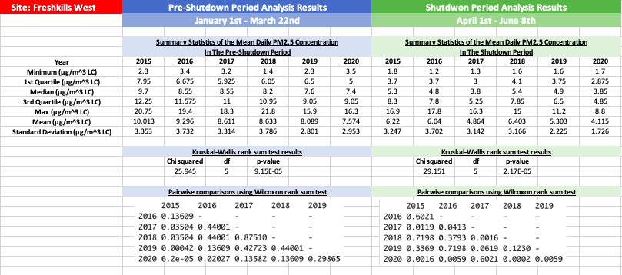

*Figure 3: Summary Statistics and Results of the Kruskal Wallis Test and the Wilcoxson Rank Sum test for Freshkills West*



*Figure 4: Comparison of PM2.5 levels during the pre-shutdown and shutdown period in Freshkills West*

As seen in figure 4, the Daily Mean PM2.5 Concentration in Freshkills West is greater during the pre-shutdown period than in the shutdown period. Throughout all 5 years, the minimum, 1st quartile, median, 3rd quartile, maximum, and mean daily mean PM2.5 concentration in the pre-shutdown period are greater than during the shutdown period except for in 2018 where the minimum daily PM2.5 concentration during the pre-shutdown period was 1.4 $μ$ g/m^3 in the shutdown period the minimum values was 1.6 $μ$ g/m^3. Like in the data from CCNY, the standard deviations do not change from the pre shutdown period to the shutdown period for each year except for in 2018 and in 2020 where in 2018 the standard deviation goes from 3.786 $μ$ g/m^3 to 3.166 $μ$ g/m^3 and in 2020 where the standard deviation decreased from 2.953 $μ$ g/m^3 to 1.726 $μ$ g/m^3 showing that in 2018 and in 2020 the measurements of PM2.5 were consistently more lower in the shutdown period than in the pre-shutdown period compared with the other years.

Based on the results of the Kruskal Wallis Test (Figure 3) , the chi squared value is 25.945 with a p-value of 9.15E-05 for the pre-shutdown period and a chi squared value of 25.151 with a p-value of 2.17e-05 meaning that during both periods, the PM2.5 daily mean concentrations for each year was statistically different and that the group medians are not equal. However, looking at the results from the Wilcoxon rank sum test, we can see that during the pre-shutdown period, the p-values comparing 2020 with 2017, 2018, and 2019 are 0.136, 0.136, and 0.299, which are all greater than 0.05 meaning that we have evidence to suggest that the PM2.5 medians were the same across 2017-2020 during the pre-shutdown period. Since the p-values comparing 2020 to 2015 and 2016 (6.2e-05 and 0.02) were less than 0.05, this suggest that the PM2.5 medians were different from 2020 so referring back to table 1, with the Kruskal Wallis test and the Wilcoxon test we cannot compare the PM2.5 concentration change from the pre-shutdown period to the shutdown period for these years because they originally started out different. However, during the shutdown period, the p-values comparing 2020 with 2017, 2018, and 2019 are 0.6021, 0.0002, 0.006. With this, the 2020 median is not statistically different than in 2017; however, comparing 2018 and 2019 to 2020, we see that 2020 had a greater decrease in PM2.5 air pollution than in 2018 and 2019 because during the pre-shutdown period, we had evidence that the medians were the same, but during the shutdown period we see that the medians are statistically different and since the median daily PM2.5 concentration in 2020 (3.85 $μ$ g/m^3) is less than the median daily mean PM2.5 concentrations in 2018 and 2019 (4.9 $μ$ g/m^3 and 5.4 $μ$ g/m^3 ), then we can see that the daily mean PM2.5 concentration in Freshkills West decreased more in 2020 during the shutdown period than it did during 2018 and 2019.

Intermediate School 143 Results/Analysis:

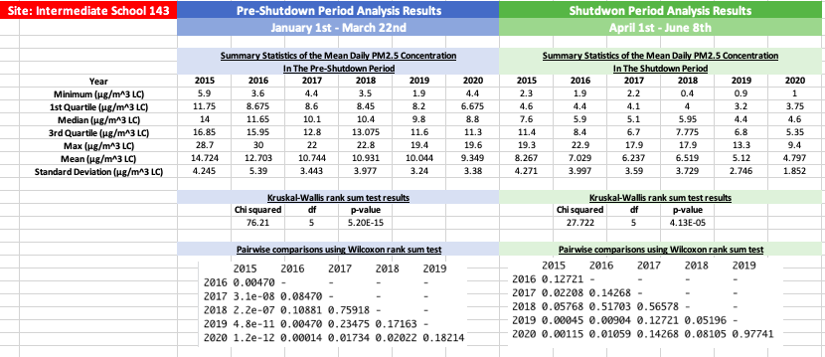

*Figure 5: Summary Statistics and Results of the Kruskal Wallis Test and the Wilcoxson Rank Sum test for Intermediate School 143*



*Figure 6: Comparison of PM2.5 levels during the pre-shutdown and shutdown period in Intermediate School 143*

As seen in figure 6, the Daily Mean PM2.5 Concentration in Intermediate School 143 is greater during the pre-shutdown period than in the shutdown period. Throughout all 5 years, the minimum, 1st quartile, median, 3rd quartile, maximum, and mean daily mean PM2.5 concentration in the pre-shutdown period are greater than during the shutdown period. Like in CCNY and Freshkills West, the standard deviations don’t change that much from the pre-shutdown period to the shutdown period each year but in Intermediate School 143 during years 2016, 2019, and 2020 the standard deviation decreases by 1.393 $μ$ g/m^3, 0.494 $μ$ g/m^3, and 2.128 $μ$ g/m^3. Even though the standard deviations are decreasing in 2016 and 2019, it decrease more in 2020 showing more consistent lower measurements of PM2.5 concentration in 2020 than in the other years.

Based on the results of the Kruskal Wallis Test (Figure 5) , the chi squared value is 76.21 with a p-value of 5.2E-15 for the pre-shutdown period and a chi squared value of 27.722 with a p-value of 4.13e-05 meaning that during both periods, the PM2.5 daily mean concentrations for each year was statistically different and that the group medians are not equal. Looking at the results from the Wilcoxon rank sum test all of the p-values comparing 2020 to the other years during the pre-shutdown period are less than 0.05 except for in 2019, which has a p-value of 0.182 meaning that the median of the distribution of mean daily PM2.5 concentrations in the pre-shutdown period is the same in 2019 and 2020. Since the p-values comparing 2020 to 2015-2018 (1.2e-12, 0.0001, 0.017, 0.02) were less than 0.05, this suggest that the PM2.5 medians were different from 2020 so referring back to table 1, with the Kruskal Wallis test and the Wilcoxon test we cannot compare the PM2.5 concentration change from the pre-shutdown period to the shutdown period for these years because they originally started out different. Looking at just 2019, the p-value comparing 2019 to 2020 is 0.977, which means that during both the pre-shutdown period and the shutdown period, the PM2.5 medians in Intermediate School 143 was statistically similar, thus the government shutdown had not impact on the decrease in PM2.5 concentration levels. This is because the PM2.5 concentration decreased by a statistically similar way in 2019 as it did it 2020, so the government shutdown had no significant effect on PM2.5 concentration at Intermediate School 143.

Intermediate School 74 (IS 74) Results/Analysis:

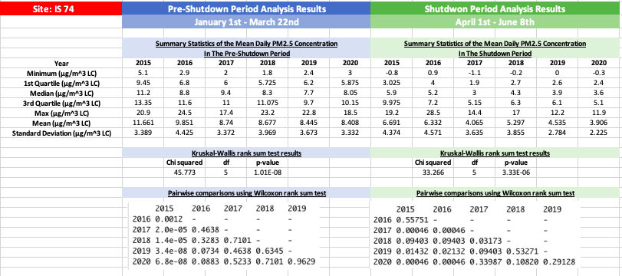

*Figure 7: Summary Statistics and Results of the Kruskal Wallis Test and the Wilcoxson Rank Sum test for IS 74*



*Figure 8: Comparison of PM2.5 levels during the pre-shutdown and shutdown period in IS 74*

As seen in figure 8, the Daily Mean PM2.5 Concentration in IS 74 is greater during the pre-shutdown period than in the shutdown period. Throughout all 5 years, the minimum, 1st quartile, median, 3rd quartile, maximum, and mean daily mean PM2.5 concentration in the pre-shutdown period are greater than during the shutdown period except for in 2016 where the maximum mean daily PM2.5 Concentration was 24.5 $μ$ g/m^3 during the pre-shutdown period while it was 28.5 $μ$ g/m^3 during the shutdown period. The same trend with the standard deviations is occurring where for most years, the standard deviation does not change much for each period, but in 2020 it decreases by 1.107 $μ$ g/m^3.

Based on the results of the Kruskal Wallis Test (Figure 7) , the chi squared value is 45.773 with a p-value of 1.01e-08 for the pre-shutdown period and a chi squared value of 33.266 with a p-value of 3.33e-06 meaning that during both periods, the PM2.5 daily mean concentrations for each year was statistically different and that the group medians are not equal. However, looking at the results from the Wilcoxon rank sum test, we can see that during the pre-shutdown period, the p-values comparing 2020 with 2016-2019 are 0.088, 0.5233, 0.719, and 0.963, which are all greater than 0.05 meaning that we have evidence to suggest that the PM2.5 medians were the same across 2017-2020 during the pre-shutdown period. Since the p-value comparing 2020 to 2015 (6.8e-08) was less than 0.05, this suggest that the PM2.5 levels were different from 2020 so referring back to table 1, with the Kruskal Wallis test and the Wilcoxon test we cannot compare the PM2.5 concentration change from the pre-shutdown period to the shutdown period for 2015 because they originally started out different. However, during the shutdown period, the p-values comparing 2020 with 2016, 2017, 2018, and 2019 are 0.00046, 0.34, 0.108, and 0.291. With this, in the shutdown period, 2020 median is not statistically different from 2017, 2018, and 2019; however, the median is statistically different than 2016 and since the median in 2016 (5.2 $μ$ g/m^3) is greater than in 2020 (3.6 $μ$ g/m^3) then we have statistical evidence to suggest that the mean daily PM2.5 Concentration decreased more in 2020 than in 2016 from the pre-shutdown period to the shutdown period in IS 74, but not for any of the other years.

Maspeth Library Results/Analysis:

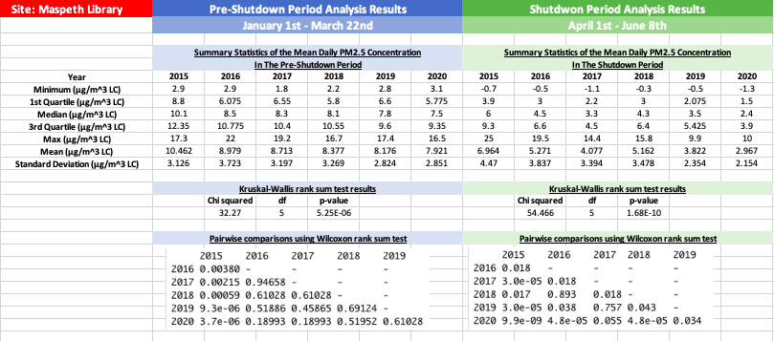

*Figure 9: Summary Statistics and Results of the Kruskal Wallis Test and the Wilcoxson Rank Sum test for Maspeth Library*



*Figure 10: Comparison of PM2.5 levels during the pre-shutdown and shutdown period in Maspeth Library*

As seen in figure 10, the Daily Mean PM2.5 Concentration in Maspeth Library is greater during the pre-shutdown period than in the shutdown period. Throughout all 5 years, the minimum, 1st quartile, median, 3rd quartile, maximum, and mean daily mean PM2.5 concentration in the pre-shutdown period are greater than during the shutdown period except in 2015 where the maximum daily mean PM2.5 concentration was 17.3 $μ$ g/m^3during the pre-shutdown period and 25 $μ$ g/m^3 during the shutdown period. In Maspeth Library, the standard deviations between the pre-shutdown period and the shutdown period stayed rather consistent, even in 2020 where it only changed by 0.697 $μ$ g/m^3. Still, this was the largest decrease in standard deviation out of all years in Maspeth Library still implying that there were consistently lower measurements of PM2.5 levels and no large measurements.

Based on the results of the Kruskal Wallis Test (Figure 9) , the chi squared value is 32.27 with a p-value of 5.25e-06 for the pre-shutdown period and a chi squared value of 54.466 with a p-value of 1.68E-10 for the shutdown period meaning that during both periods, the PM2.5 daily mean concentrations for each year was statistically different and that the group medians are not equal. However, looking at the results from the Wilcoxon rank sum test, we can see that during the pre-shutdown period, the p-values comparing 2020 to 2016-2019 (0.19, 0.19, 0.52, and 0.61) are all greater than 0.05 meaning that they are statistically similar. Since the p-value comparing 2020 to 2015 (3.7e-06) was less than 0.05, this suggest that the PM2.5 levels were different from 2020 so referring back to table 1, with the Kruskal Wallis test and the Wilcoxon test we cannot compare the PM2.5 concentration change from the pre-shutdown period to the shutdown period for 2015 because they originally started out different. Looking at the shutdown period, the p-values comparing 2020 to 2016-2019 (4.8e-05, 0.055, 4.8e-05, and 0.034) are all less than 0.05 meaning that the distributions are statistically different. From these results, we can see that the PM2.5 medians were the same for 2020 as years 2016-2019 in the pre-shutdown period and different in the shutdown period, which means that the PM2.5 levels changed differently from the pre-shutdown period to the shutdown period in 2020 than in other years. Looking at the median daily PM2.5 concentration for the years 2016-2020 in the shutdown period (6.6 $μ$ g/m^3, 4.5 $μ$ g/m^3, 6.4 $μ$ g/m^3, 5.425 $μ$ g/m^3, and 3.9 $μ$ g/m^3) we can see that the 2020 median was the least. This shows us that compared to other years (2016-2019), in 2020 the PM2.5 daily mean concentration decreased in Maspeth Library the most which supports the hypothesis that the COVID-19 government shutdown decreased air pollution.

Morrisania Results/Analysis:

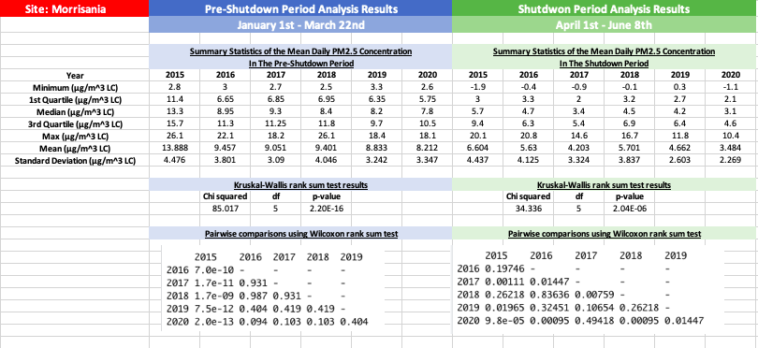

*Figure 11: Summary Statistics and Results of the Kruskal Wallis Test and the Wilcoxson Rank Sum test for Morrisania*



*Figure 12: Comparison of PM2.5 levels during the pre-shutdown and shutdown period in Morrisania*

As seen in figure 12, the Daily Mean PM2.5 Concentration in Morrisania is greater during the pre-shutdown period than in the shutdown period. Throughout all 5 years, the minimum, 1st quartile, median, 3rd quartile, maximum, and mean daily mean PM2.5 concentration in the pre-shutdown period are greater than during the shutdown period. In Morrisania, the standard deviations between the pre-shutdown period and the shutdown period stayed rather consistent for years 2015-2018, but in 2019 and 2020 the standard deviation of the PM2.5 mean daily concentration changed from the pre-shutdown period to the shutdown period by 0.639 $μ$ g/m^3 and 1.078 $μ$ g/m^3, which shows more consistently lower measurements in the years 2019 and 2020.

Based on the results of the Kruskal Wallis Test (Figure 11) , the chi squared value is 85.017 with a p-value of 2.2e-16 for the pre-shutdown period and a chi squared value of 34.336 with a p-value of 2.04e-6 for the shutdown period meaning that during both periods, the PM2.5 daily mean concentrations for each year was statistically different and that the group medians are not equal. However, looking at the results from the Wilcoxon rank sum test, we can see that during the pre-shutdown period, the p-values comparing the year 2020 with 2017-2019 (0.103, 0.103, 0.404) are all greater than 0.05 meaning that we have evidence to suggest that the medians of the daily PM2.5 daily concentrations were the same across 2017-2020 during the pre-shutdown period. Since the p-value comparing 2020 to 2015 and 2016 (2e-13 and 0.094) was less than 0.05, this suggest that the PM2.5 levels were different from 2020 so referring back to table 1, with the Kruskal Wallis test and the Wilcoxon test we cannot compare the PM2.5 concentration change from the pre-shutdown period to the shutdown period for 2015 because they originally started out different. Looking at the shutdown period, the p-values comparing 2020 to 2017-2019 (0.494, 0.001, 0.014) we don’t have evidence to suggest that the distribution in 2020 is different than the distribution in 2017; however we do have evidence to suggest that the median in 2020 was different than in 2018 and 2019. This means that the PM2.5 daily mean concentration had a significant decrease in 2020 compared to 2018 and 2019, but not compared to 2017. Also the median PM2.5 daily mean concentration during the shutdown period in 2020 (3.1) was less than that in 2017-2019 (3.4, 4.5, 4.2).

Pfizer Lab Site Results/Analysis:

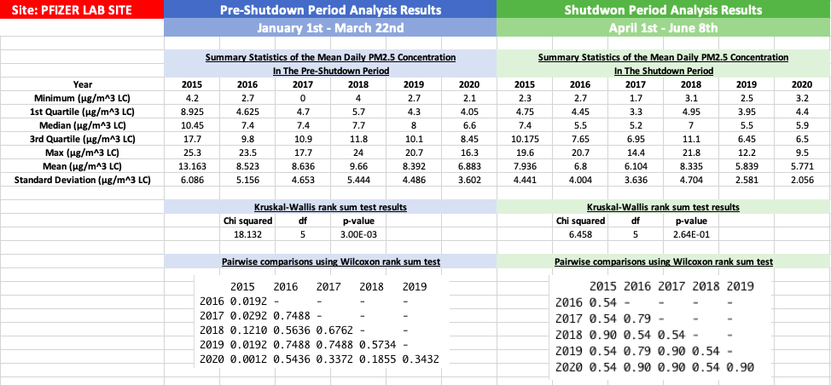

*Figure 13: Summary Statistics and Results of the Kruskal Wallis Test and the Wilcoxson Rank Sum test for Pfizer Lab Site*



*Figure 14: Comparison of PM2.5 levels during the pre-shutdown and shutdown period in Pfizer Lab Site*

As seen in figure 14, the Daily Mean PM2.5 Concentration in Pfizer Lab Site is greater during the pre-shutdown period than in the shutdown period. Throughout all 5 years, the minimum, 1st quartile, median, 3rd quartile, maximum, and mean daily mean PM2.5 concentration in the pre-shutdown period are greater than during the shutdown period except for in 2020 where the 1st quartile of the mean daily PM2.5 Concentration was 4.05 $μ$ g/m^3 during the pre-shutdown period while it was 4.4 $μ$ g/m^3 during the shutdown period and the minimum mean daily PM2.5 Concentration in 2017 and 2020 (0 $μ$ g/m^3, 2.1 $μ$ g/m^3) during the pre-shutdown period and (1.7 $μ$ g/m^3, 3.2 $μ$ g/m^3) during the shutdown period. The standard deviations decreased more from the pre-shutdown period to the shutdown period across all years unlike the other sites (they all decreased around 1 $μ$ g/m^3)

Based on the results of the Kruskal Wallis Test (Figure 13) , the chi squared value is 18.132 with a p-value of 3e-3 for the pre-shutdown period and a chi squared value of 6.458 with a p-value of 2.64e-1 for the shutdown period meaning that during both periods, the PM2.5 daily mean concentrations for each year was statistically different and that the group medians are not equal. However, looking at the results from the Wilcoxon rank sum test, we can see that during the pre-shutdown period, the p-values comparing the year 2020 to the years 2016-2019 (0.544, 0.337, 0.186, 0.343) are all greater than 0.05, so there is evidence to suggest that the distributions in 2020 is similar to the distribution in the years 2016-2019 during the pre-shutdown period. Since the p-value comparing 2020 to 2015 (0.001) was less than 0.05, this suggest that the PM2.5 levels were different from 2020 so referring back to table 1, with the Kruskal Wallis test and the Wilcoxon test we cannot compare the PM2.5 concentration change from the pre-shutdown period to the shutdown period for 2015 because they originally started out different. During the shutdown period, the p-values comparing 2020 to 2016-2019 (0.9, 0.9, 0.54, and 0.9) are all greater than 0.05, so again there is evidence to suggest that they are all statistically similar meaning that there was no significant decrease in the PM2.5 levels in 2020 compared to the years 2016-2019. Thus, there is no evidence in Pfizer Lab site to suggest that the NYC government shutdown decreased the air pollution; however, while computing all of the p-values in R using the Kruskal Wallis and Wilcoxon test, there was a warning stating that it “could not compute exact p-values with ties”, making our interpretation and results for Pfizer Lab Site less certain.

Public School 274 (PS 274) Results/Analysis:

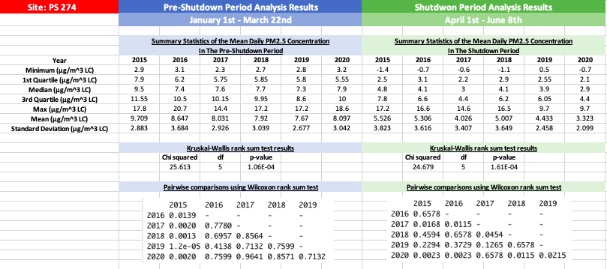

*Figure 15: Summary Statistics and Results of the Kruskal Wallis Test and the Wilcoxson Rank Sum test for PS 274*



*Figure 16: Comparison of PM2.5 levels during the pre-shutdown and shutdown period in PS 274*

As seen in figure 16, the Daily Mean PM2.5 Concentration in PS 274 is greater during the pre-shutdown period than in the shutdown period. Throughout all 5 years, the minimum, 1st quartile, median, 3rd quartile, maximum, and mean daily mean PM2.5 concentration in the pre-shutdown period are greater than during the shutdown period except for in 2017 where the maximum in the pre-shutdown period (14.4 $μ$ g/m^3) was less than in the shutdown period (14.6 $μ$ g/m^3). In other sites, the standard deviations tended to decrease from the pre-shutdown period to the shutdown period; however, in 2015, 2017, 2018, and 2019 the standard deviations increased from about 0.6 $μ$ g/m^3 to 1 $μ$ g/m^3 while in 2020 the standard deviation decreased by 0.943 $μ$ g/m^3.

Based on the results of the Kruskal Wallis Test (Figure 15) , the chi squared value is 25.613 with a p-value of 1.06e-4 for the pre-shutdown period and a chi squared value of 24.679 with a p-value of 1.61e-4 for the shutdown period meaning that during both periods, the PM2.5 daily mean concentrations for each year was statistically different and that the group medians are not equal. However, looking at the results from the Wilcoxon rank sum test, we can see that during the pre-shutdown period, the p-values comparing the year 2020 to the years 2016, 2017, 2018, and 2019 (0.76, 0.964, 0.857, 0.713) are all greater than 0.05, so we have evidence to suggest that the distribution in 2020 is similar to the distributions in the years 2016-2019 during the pre-shutdown period. Since the p-value comparing 2020 to 2015 (0.002) was less than 0.05, this suggest that the PM2.5 levels were different from 2020 so referring back to table 1, with the Kruskal Wallis test and the Wilcoxon test we cannot compare the PM2.5 concentration change from the pre-shutdown period to the shutdown period for 2015 because they originally started out different. In the shutdown period, the p-values comparing 2020 10 2016-2019 are 0.0023, 0.6578, 0.0115, and 0.0215. In 2017, the p-value was greater than 0.05, so that means that there is no evidence that the COVID shutdown effected the decrease in PM2.5 levels in PS 274 because the distributions in 2017 and 2020 are not statistically different in either period. However, in 2016, 2018, and 2019, the p-values are all lower than 0.05, so each of these distributions is different than 2020. Since the median PM2.5 daily mean concentration in 2020 during the shutdown period (2.9 $μ$ g/m^3) is less than that of 2016, 2018, and 2019 (4.1 $μ$ g/m^3, 4.1 $μ$ g/m^3, 3.9 $μ$ g/m^3), we can see that the PM2.5 daily mean concentration decreased more in 2020 in PS 274 than it did in 2016, 2018, and 2019, which could be due to the government shutdown in 2020.

Public School 314 (PS 314) Results/Analysis:

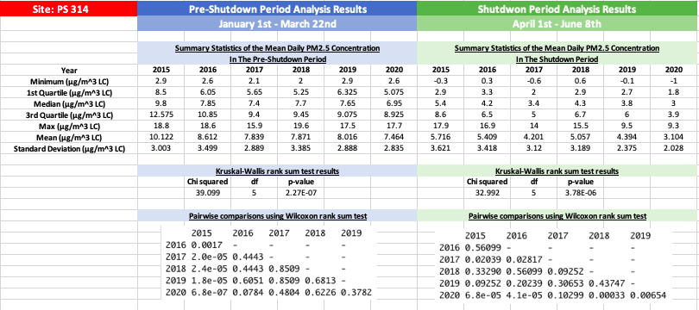

*Figure 17: Summary Statistics and Results of the Kruskal Wallis Test and the Wilcoxson Rank Sum test for PS 314*



*Figure 18: Comparison of PM2.5 levels during the pre-shutdown and shutdown period in PS 314*

As seen in figure 18, the Daily Mean PM2.5 Concentration in PS 314 is greater during the pre-shutdown period than in the shutdown period. Throughout all 5 years, the minimum, 1st quartile, median, 3rd quartile, maximum, and mean daily mean PM2.5 concentration in the pre-shutdown period are greater than during the shutdown. Additionally the standard deviation did not change much from the pre-shutdown period to the shutdown period and decreased the most during 2020 (by 0.87 $μ$ g/m^3).

Based on the results of the Kruskal Wallis Test (Figure 17) , the chi squared value is 39.099 with a p-value of 2.27e-07 for the pre-shutdown period and a chi squared value of 32.992 with a p-value of 3.78e-06 for the shutdown period meaning that during both periods, the PM2.5 daily mean concentrations for each year was statistically different and that the group medians are not equal. However, looking at the results from the Wilcoxon rank sum test, we can see that during the pre-shutdown period, the p-values comparing the year2020 to the years 2016, 2017, 2018, and 2019 (0.078, 0.48, 0.623, 0.378) are all greater than 0.05, so we have evidence to suggest that the distribution in 2020 is similar to the distributions in the years 2016-2019 during the pre-shutdown period. Since the p-value comparing 2020 to 2015 (6.8e-7) was less than 0.05, this suggest that the PM2.5 levels were different from 2020 so referring back to table 1, with the Kruskal Wallis test and the Wilcoxon test we cannot compare the PM2.5 concentration change from the pre-shutdown period to the shutdown period for 2015 because they originally started out different. In the shutdown period, the p-values comparing 2020 10 2016-2019 are 4.1e-05, 0.103, 0.0003, 0.007, so the distributions in 2017 and 2020 during the shutdown period are statistically similar; however, we have evidence to suggest that in 2016, 2018, and 2019, the median of the distribution was statistically different than that in 2020 during the shutdown period. Since the median in 2020 (3 $μ$ g/m^3) was less than the median in 2016, 2018, 2019 (4.2 $μ$ g/m^3, 4. $μ$ g/m^33, 3.8 $μ$ g/m^3), this mean that the PM2.5 concentration decreased more in 2020 than in 2016, 2018, and 2019, which could be due to the government shutdown.

Overall, in CCNY, Freshkills West, IS 74, Maspeth Library, Morrisania, PS 274, and PS 314 there is some evidence to suggest that the NYC government mandated shutdowns did in fact decrease the PM2.5 daily mean concentration because the decrease in 2020 from the pre-shutdown period to the shutdown period was statistically different than in some past years. However, in Intermediate School 143 and Pfizer Lab Site, there was no evidence that the decrease in the daily mean PM2.5 concentration was due to the NYC government mandated shutdown. Additionally, it is important to note that in all sites, the year 2015 could never be considered for our analysis in the same way as other years because for every site, during the pre-shutdown period the median PM2.5 daily mean concentration was never similar to that in 2020. Also, there was a trend that the later years were more similar to 2020, which could be because the air pollution overall is decreasing throughout time.

*****Figure 19: Comparing the Difference of the PM2.5 daily mean concentration medians of the Pre-Shutdown period (January 1st – March 16th ) to the Shutdown Period (April 1st – June 8th ) across all years and all sites*

In figure 19 above, we can compare the difference of the PM2.5 daily mean concentration medians of the pre-shutdown period and the shutdown period. It is important to notice that every single value on this chart is positive meaning that for every single year and every single site, the median PM2.5 daily mean concentration was greater during the pre-shutdown period than during the shutdown period. From this we can see that in general the pre-shutdown period PM2.5 levels are greater during the pre-shutdown period in NYC. One hypothesis of this can be because in New York City it is colder during our defined pre-shutdown period and during the shutdown period the temperatures are usually nicer, so less people and industries would be using heat. Even though all of the differences are positive on this graph, we can also see that the values for 2020 do not appear to be greater than any of the other years, which implies that the decrease in PM2.5 levels in 2020 was not significant compared to past years. If the decrease in 2020 was greater than in past years, that could be due to the government shutdown; however, in our case it is not, so there is not a lot of evidence here that the decrease in PM2.5 levels during the shutdown period can be due the shutdown.

**Summary/Conclusions:**

Ultimately, we did not find overarching statistical evidence that the New York City Government mandated shutdown had a significant effect on the PM2.5 levels. However, we did find evidence of a seasonal change in the PM2.5 levels because the PM2.5 levels in the winter seasons (pre-shutdown period) were always less than the PM2.5 levels during the Spring (shutdown period).

The following graphs published online by other studies show misleading graphs that only show data from 2020, thus deceiving the public upon first glance that the COVID shutdowns are decreasing the air pollution. These websites go on to explain that these could be due to seasonal effects; however, the headline of these articles and the graphs are tricky to the public and it is easy to get misinformed that the decrease in PM2.5 concentrations is due purely to the COVID shutdowns without looking at the bigger picture.

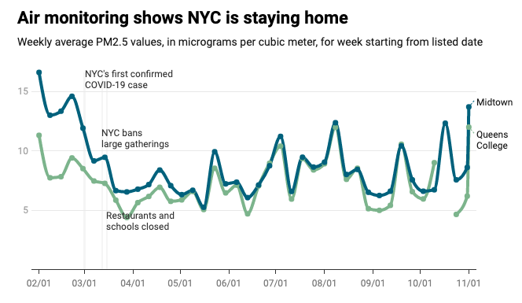

**<http://a816-dohbesp.nyc.gov/IndicatorPublic/Closerlook/covidair/>**

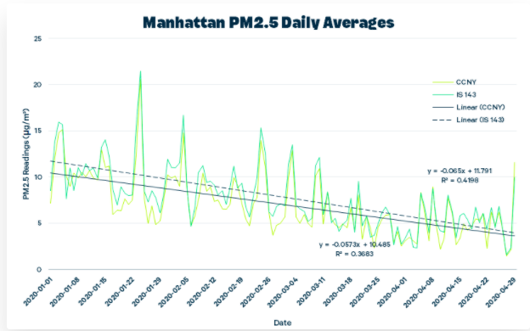

[**https://learn.kaiterra.com/en/air-academy/data-study-covid-19-pandemic-pm2.5-nyc**](https://learn.kaiterra.com/en/air-academy/data-study-covid-19-pandemic-pm2.5-nyc)

Overall, we did not find major evidence that the NYC government shutdown had a significant effect on the PM2.5 concentration; however, if we were to look at another pollutant say NO2 or CO that is produced mainly by traffic (which was definitely less during the government shutdown and is not effected by season), then we might be able to see an effect from the shutdown. Additionally, if we were to look at data after phase 1 where NYC wasn’t completely shut down, but definitely less busy than previous years, we would be able to look at more months of data and be able to see either a rise or fall of PM2.5 due to stuff opening up again. Also in the future, this experiment could be repeated to see if the PM2.5 levels rise when things start to go back to normal after the pandemic.

**Github Link:**

**Sources:**

[**https://www.aqi.in/blog/here-are-the-10-main-causes-of-air-pollution/**](https://www.aqi.in/blog/here-are-the-10-main-causes-of-air-pollution/)

[**https://climatekids.nasa.gov/air-pollution/#:~:text=The%20Short%20Answer%3A,our%20air%20are%20called%20aerosols**](https://climatekids.nasa.gov/air-pollution/#:~:text=The%20Short%20Answer%3A,our%20air%20are%20called%20aerosols)**.**

[**http://a816-dohbesp.nyc.gov/IndicatorPublic/traffic/index.html#:~:text=5-,PM2.,commercial%20cooking%20and%20industrial%20activities**](http://a816-dohbesp.nyc.gov/IndicatorPublic/traffic/index.html#:~:text=5-,PM2.,commercial%20cooking%20and%20industrial%20activities)**.**

[**https://allthatsinteresting.com/new-york-city-smog-1966**](https://allthatsinteresting.com/new-york-city-smog-1966)

[**https://www.investopedia.com/historical-timeline-of-covid-19-in-new-york-city-5071986**](https://www.investopedia.com/historical-timeline-of-covid-19-in-new-york-city-5071986)